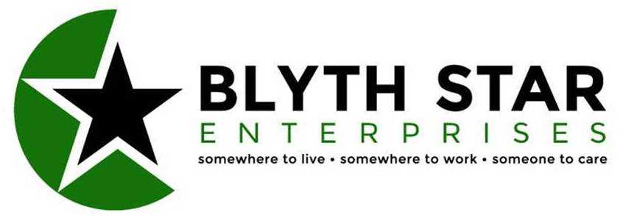

BLYTH STAR ENTERPRISES LIMITED
JOB DESCRIPTION

Job Details

Job Title: Support Worker
Hours: Ad-Hoc
Location: Community Rehabilitation/Living Support Services
Responsible To: Senior Services Manager

Job Purpose

To participate in the delivery of the assessment, planning, implementation and evaluation of care and support to people supported by Blyth Star Enterprises Community Rehabilitation/Living Support Services in accordance with the Care Standards Act and other appropriate legislation or contractual standards.

Area of Involvement

The Community Rehabilitation/Living Support Services Team currently supports over 130 people within Central and South East Northumberland. This number is subject to regular change.

Knowledge, Skills and Experience Required

Experience of working with people with enduring mental health problems an advantage.
NVQ qualification in Health & Social Care (Adults) preferred.
A commitment to undertake appropriate training is essential.
The ability to work as part of a team, but also to work independently.
A commitment to working in a person centred manner.
An understanding and commitment to the Mental Health Recovery model an advantage.
An ability to work a range of hours including nights on a rotational basis.
Full clean driving licence preferred.

Working Relationship/Communication

To work within an already established team.
To work in collaboration with other professionals ensuring good lines of communication, both written and verbal, thus ensuring a multi-professional concept of care is delivered.
To communicate effectively with clients and their families/carers in promoting an awareness and understanding of their individualised care and support plans.

Key Result Areas

To fully comply with the policies and procedures of Blyth Star Enterprises and ensure statutory responsibilities are met.

To participate in meetings or working groups designed to look at particular needs involved in the delivery of support to the people who receive a service.

To establish and maintain effective relationships with other agencies and disciplines involved in the delivery of care to the people who receive a service.

To undertake a Key Worker role and formulate, implement and monitor support plans in partnership with the person receiving support.

To support individuals to use the Mental Health Recovery model as a way of developing their independence and gaining control over their lives.

Working as part of a team to provide support and assistance to all people receiving a service, not just those for whom you may act as Key Worker.

Supervise and support clients in all aspects of daily living, social and leisure activities.

Support clients with monitoring their mental health, reviewing and maintaining their coping strategies.

To support clients as required when using agencies involved in their mental/physical care and act in the role of advocate as necessary.

To work as part of a multi-disciplinary team that promotes a culture of choice that entails responsible, supported decision-making and risk enablement.

Monitor the taking of clients' medication according to their Person Centred Plan.

To participate in a formal appraisal system and undergo any training identified.

To participate in the staffing rota including night duty as required.

To undertake sleep-in duty as and when required.

Most Challenging Part of the Job

Ensuring that each individual is supported in a person centred way.

Contributing to the planning and development of the Community Rehabilitation/
Living Support Services to ensure a high standard of support is provided to everyone who uses the service.

Description Agreement

Post Holder's Signature: Date:

Senior Services Manager's Signature: Date:

